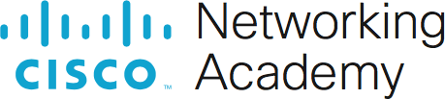

Packet Tracer - WAN Concepts

# Objectives

In this activity, you will investigate various types of WANs by exploring a topology that uses diverse connectivity technologies.

* Describe different WAN connectivity options.

# Background / Scenario

You will explore WAN technologies that are used to connect business and home users to data services.

**Note:** There is no scoring in this activity.

# Instructions

**Part 1: Investigate Consumer WAN Technologies for Home and Mobile Devices.**

## Step 1: Explore Consumer WAN Technologies.

In this step, you will explore three consumer WAN technologies and home networks.

1. Look at the two home networks.

What are the WAN technologies in use?

- Según los cuadros que se encuentran, se usa una Home Cable Network y un Home DSL Network, además de una red celular Cellular Network.

1. Examine the connections used in the network topology by selecting the Connections icon (the orange lightning bolt) in the PT devices menu. Hover over the media icons to display their names in the white box at the bottom of the PT window.

What media is used to connect the two home networks to the ISP? What devices in the home networks are directly connected to the ISP?

- Al colocar el cursor encima de los cables, y compararlos con los cables que se encuentran en [Connections], los 2 tipos de cables que se usan son un coaxial (azul que parece un rayo) y uno “Phone” (negro entrecortado que parece rayo).

1. Click the DSL modem and open the Physical tab.

What ports are available on the device and what is connected to them?

- En la parte de vista física, hay 2 puertos, uno que dice “LINE 0” el cual es para la línea telefónica, y otro que dice “FAST ETHD” que es para conexiones Fast Ethernet.

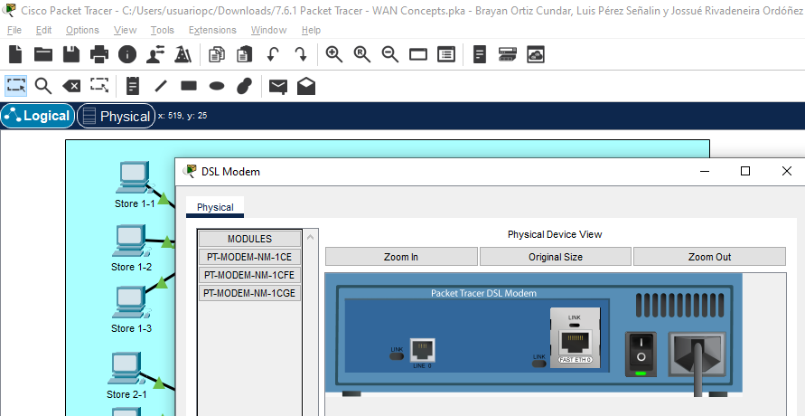

What is the purpose of the DSL modem?

- Su función es la de convertir la línea DSL (la cual es la línea telefónica) en una conexión Ethernet (El Fast Ethernet).

What is the type of connection between the ISP/Telco/Cable Company network and the Home Cable Network? Why is the splitter necessary?

- La conexión es a través de un cable coaxial; y el divisor es necesario, para enviar los diferentes tipos de datos entre el modem y el televisor.

1. Look at the ports on the cable modem.

What does the cable modem do? What connections does it have?

- Permite la transmisión de datos y la conexión a internet; sus conexiones son, desde el divisor coaxial, conexión con cable coaxial; y al “Wireless Router” a través de un cable “Copper Straight-Through” siendo el Fast Ethernet.

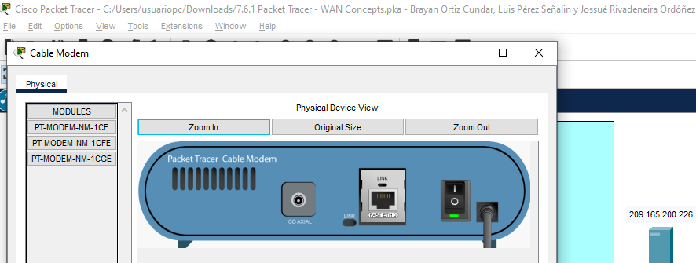

Which port does the cable from the cable modem connect to on the home wireless router? Where did the interface IP address come from?

- Conociendo que tiene 5 interfaces para conectar físicamente, sabemos que se encuentra conectado al de Internet, puesto que el resto se encuentra sin usar; y su dirección IP es dada por DHCP.

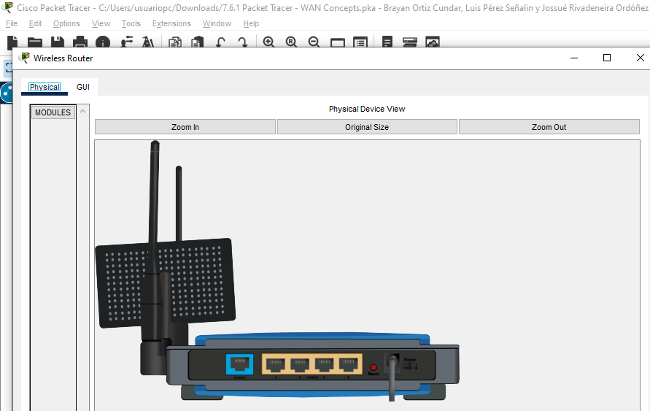

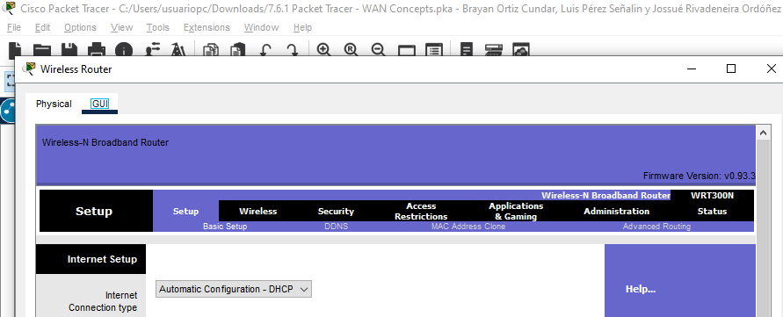

1. Look at the Smartphone.

What is its IP address? Where did the IP address come from?

- Su dirección IP es 198.51.100.100 y esta dirección debió ser provista por la torre celular a través de la red celular.

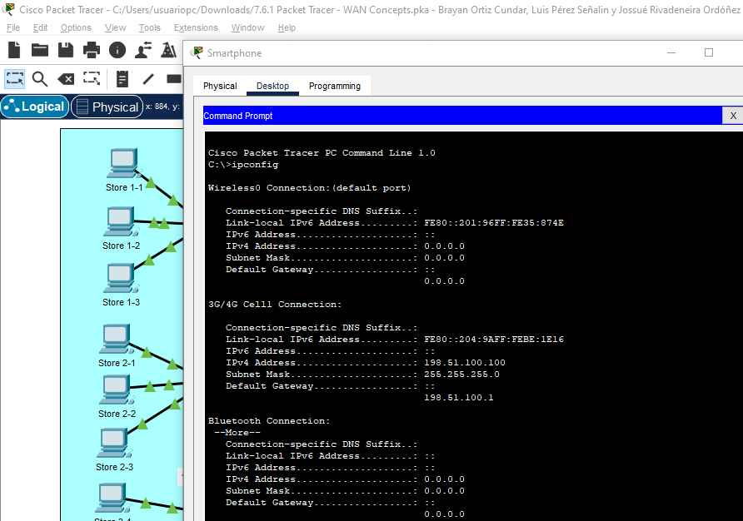

What data service is the cellphone currently using (cellular data or Wi-Fi)?

- Como se puede ver en la imagen, está usando una red celular 3G/4G.

## Step 2: Explore the Business WAN

In this step you will explore the business WAN. The business is a retail tire store. It has a local headquarters where most of the business functions occur, and three stores that are connected to the business WAN.

1. Look at the Connections menu.

What different types of connections do you see in use in the Business network?

- Se puede ver el uso de una conexión serial entre el ISP/Telco y el router Business Headquarters, el resto de conexiones son a través del cable “Copper Straight-Through” y unas conexiones de cable color rojo que se conectan en “Gigabit Ethernet” (al parecer esto indica que es un cable de fibra óptica).

1. Open the physical view for the StoreNet switch.

What types of interfaces are present? You may need to zoom and scroll the view to see.

- Tiene puertos Gigabit Ethernet, unas llamadas GLC-LH-SMD y a lado de estas un GLC-TE que al parecer es un TE4.

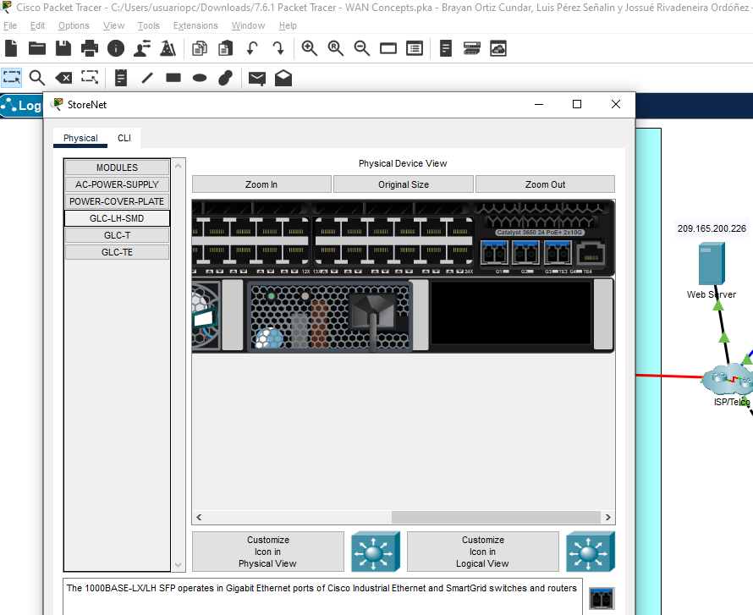

Which interfaces and media are used to connect the store networks to the Business Headquarters network? Why was this done?

- Todas las interfaces son “Gigabit Ethernet”, y 3 de éstas son de fibra óptica por el color rojo; una posible razón del uso es por una alta necesidad en la velocidad de transferencia de datos.

What type of WAN service is used to connect the Business Headquarters router to the ISP?

- Usa una conexión de tipo serial.

# Part 2: Explore Connectivity

Ping devices within the Business WAN and the Consumer WAN networks. Also ping between the networks and the between the networks and the web server. Can all hosts ping each other and the web server?

Is this a good situation?